1. How would you use ps to display all processes running on the system, not just those owned by the current user?

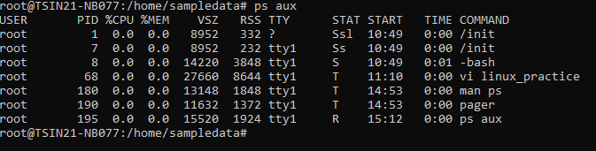

2. What is the difference between ps -e , ps -f , and ps -ef ? Provide examples.

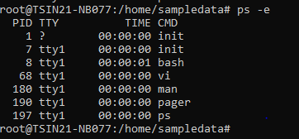

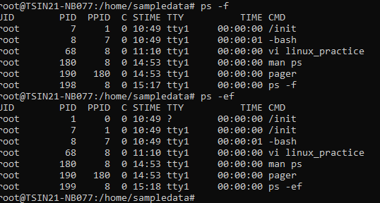

3. How can you use ps to find the PID of a specific process (e.g., nginx )?

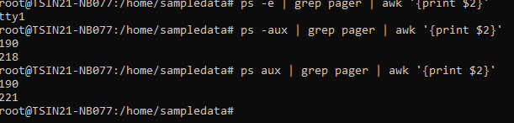

4. How can you display hierarchical information about parent and child processes using ps ?

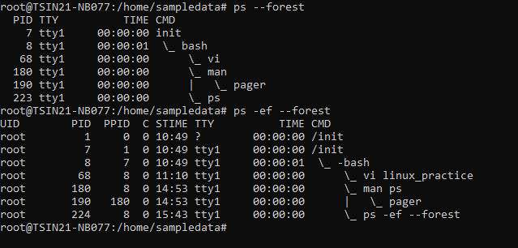

5. What is the difference between top and htop ? Why might you prefer one over the other?

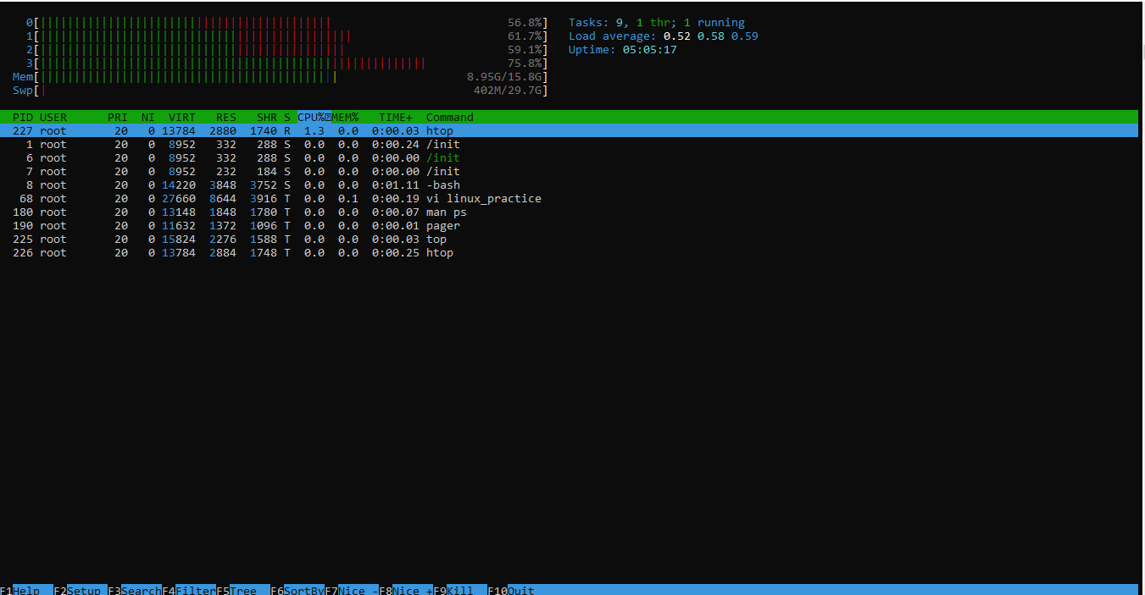

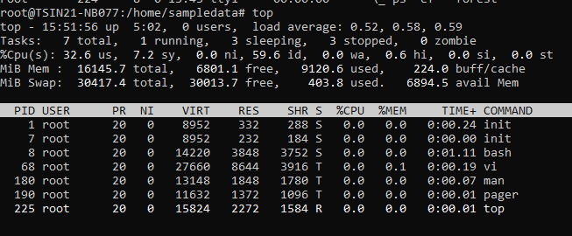

7. How can you monitor processes belonging to a specific user using top?

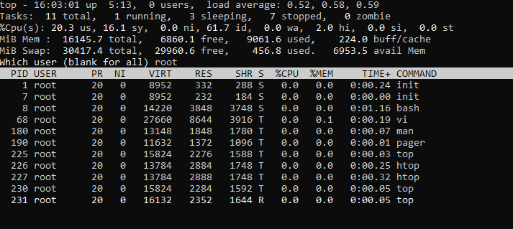

8. How can you use htop to search for a specific process?

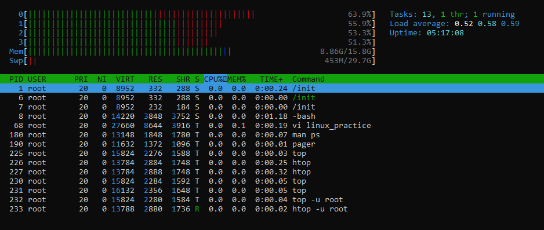

9. Explain the significance of the load average displayed in top . What do the three numbers represent?

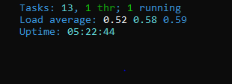

11. What is the syntax for using kill to terminate a process with a known PID?

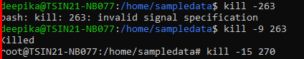

13. How can you kill all processes owned by a specific user using kill ?

**Kill –9 $(ps –u deepika –o pid)**

15. How can you ensure pkill only terminates processes owned by a specific user?

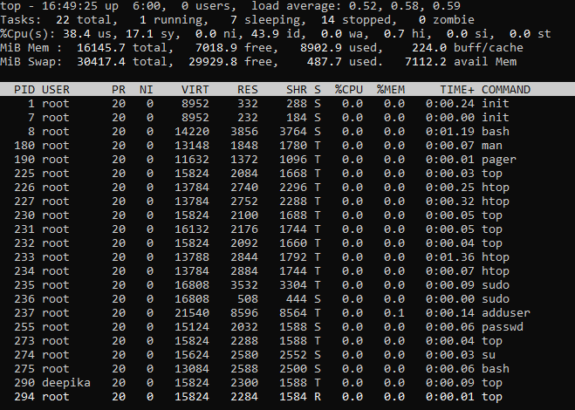

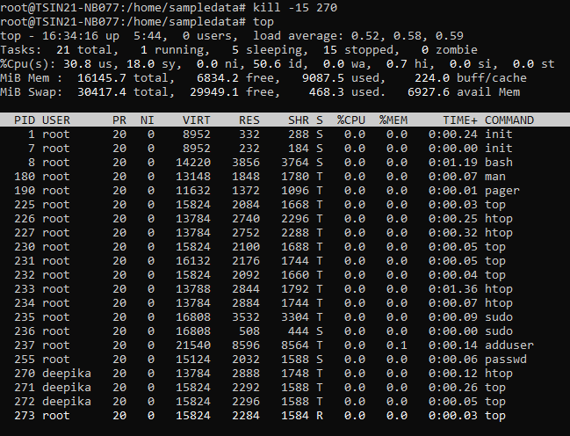

17. What is the purpose of nice ? How do you start a process with a lower priority?

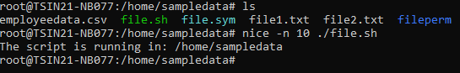

18. How can you change the priority of a running process using renice ?

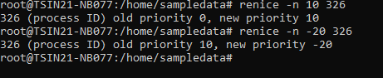

20. How can you check the priority of a process?

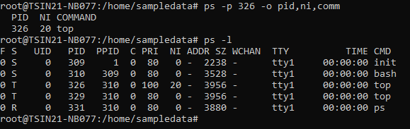

21. What does nohup do, and why is it useful? Provide an example.



22. Where does nohup store the output of a command by default? How can you change this?

We can change this by following below:

